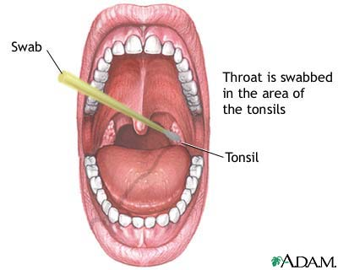

- Procedure
  - Add 3 drops of Reagent 1 to an extraction tube. This solution should be pink.
  - Add 3 drops of Reagent 2 to the same tube. This solution should turn yellow.
  - Place the specimen swab in the tube. Place the swab in the solution and vigorously mix the solution with the swab at least ten (10) times. Allow to stand for 1 (one) minute.
  - Express the liquid from the swab by squeezing the tube with the thumb and forefinger and rotating the swab as it is withdrawn. The liquid must be thoroughly removed from the swab. Discard the swab.
  - Remove test stick from the container and re-cap the container immediately.
  - Place the absorbent end of the test stick into the extracted sample.
  - Set a timer for five (5) minutes. At the end of five minutes, the results are read. Some positive (blue line) results may be read earlier. Red = control line
  - A throat culture for Beta Strep may be set up on negative screen results.

- If strep test is negative
- Back-up agar culture may be indicated
- Gold Standard is the agar culture
- Secondary specimen may be sent to a local lab with which you have an agreement
- Referral to the physician if patient worsens or symptoms do not improve

- If strep test is positive
- Antibiotic therapy will be prescribed per protocol
  - Penicillin antibiotic of choice
  - See Appendix One: Prescriptive Authority Protocol
- Supportive OTC recommendations
    - Acetaminophen
    - Gargles, lozenges, throat spray
    - Fluids
    - Bed Rest

