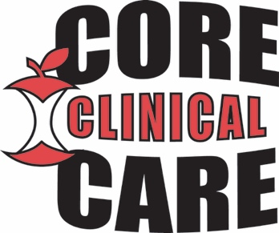

Core Clinical Care Diabetes and Education Center
A Division of Apple Discount Drugs
FAX 410-860-1155 PHONE 410-749-8401

Patient Referral Cover Sheet

Date______________

Patient Name ____________________________________________________________

Patient Birthdate __________________________________________________________

Referring Provider _________________________________________________________

Please schedule a meeting with the above individual for diabetes self-management education.
I have included the following information:

_______ Signed and completed referral form with diagnosis code

_______ Most recent patient encounter notes

_______ Most recent blood work

Special comments_____________________________________________________________

____________________________________________________________________________

Signature____________________________________________

-Please fax this form with all supporting data to the above number-

Community Pharmacy Foundation | GTwigg - Grant #143 | http://www.communitypharmacyfoundation.org/grants/grants_list_details.asp?grants_id=70981

