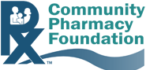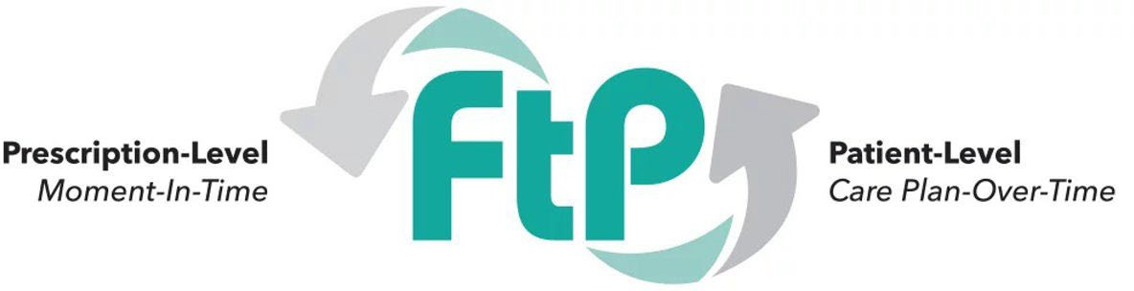

Request for Proposals
Priority Theme – Advancing Interoperability in Community Pharmacy Practice
Overview of the Funding Opportunity
The Community Pharmacy Foundation (CPF) invites proposals to support projects that advance interoperability in community pharmacy practice. Interoperability is foundational to advancing community pharmacy from a dispensing role to a fully integrated healthcare provider. From 2019 to 2026, the Community Pharmacy Foundation (CPF) invested over seven million dollars to support its signature community pharmacy practice transformation program, Flip the Pharmacy (FtP). Flip the Pharmacy was designed to help community pharmacies build the infrastructure, efficiencies, and resource optimization strategies needed to deliver patient care services. FtP equips pharmacies with practical tools, resources, and dedicated coaching support to transform their practices and expand their capacity to provide high-quality, longitudinal patient care. Additional information about Flip the Pharmacy can be found at www.flipthepharmacy.com.
Despite significant progress in practice transformation, gaps in interoperability can limit community pharmacists’ ability to deliver coordinated, team-based care. As highly accessible providers, pharmacists are well positioned to support ongoing longitudinal patient care but often lack access to critical clinical data. Interoperability connects community pharmacies to the broader healthcare ecosystem, enabling the exchange of essential information to strengthen care coordination, support transitions of care, and improve patient care.
This RFP seeks to fund projects that design, implement, and evaluate scalable approaches to interoperability—enabling community pharmacies to seamlessly exchange, access, and use patient health data with other parts of the healthcare system (e.g., EHRs, healthcare providers health systems, payers, labs, etc.). CPF seeks projects that move beyond concept to real-world implementation, demonstrating how interoperability can meaningfully improve care delivery, coordination, and outcomes in community pharmacy practice. Project proposals should demonstrate how interoperability enables community pharmacies to seamlessly exchange, access, and use patient health data across the healthcare system to support high-quality patient care. Proposed activities may include, but are not limited to, medication optimization, chronic disease management (e.g., diabetes, hypertension), transitions of care, preventive services (e.g., immunizations), and integration of social determinants of health.

Purpose of RFP
The purpose of this RFP is to support projects that:
- Test real-world interoperability solutions in community pharmacy settings
- Enable bidirectional exchange of clinical data between community pharmacies and key stakeholders
- Strengthen pharmacists’ ability to deliver longitudinal care aligned with FtP practice transformation
- Embed interoperable data into routine pharmacy workflow and care processes
- Demonstrate the impact of data sharing on patient care, workflow, care coordination, and/or outcomes
- Identify scalable, sustainable models for broader adoption
- Advance the integration of community pharmacy into the healthcare ecosystem

Example Project Types
Competitive proposals may include (but are not limited to):
- Connecting community pharmacies to HIEs/QHINs to enable real-time access to patient data
- Implementing pharmacist documentation that flows between pharmacy systems and provider EHRs
- Enabling bidirectional care plans between pharmacists and care teams
- Sharing electronic lab data between providers to support patient care

Project Priority Areas
Proposals should emphasize connecting pharmacies to the broader healthcare ecosystem to facilitate longitudinal patient care and care coordination. Proposals should address the following priority areas:
Data Exchange & Integration
- Integration with EHRs, Health Information Exchanges (HIEs), QHINs or payer systems
- Use of nationally recognized standards (e.g., HL7 FHIR, Pharmacist eCare plan)
- Bidirectional data sharing (not one-way feeds)
Workflow & Practice Transformation
- Embedding data into pharmacy workflows
- Enhancing pharmacist clinical decision-making
- Supporting longitudinal patient care models

Funding & Timeline
RFP Release Date: April 24, 2026
Opportunity for Priority Review: Proposals received by May 27, 2026 will be evaluated by the review committee in June 2026. Awards from the priority review round will be announced in July 2026.
Open Application: The Request for Proposals will remain open until July 24, 2026. Proposals received between May 28, 2026 – July 24, 2026 will be evaluated by the review committee in late August. Awards from this round of reviews will be announced in September 2026.

Timeline for Completion: Projects should ideally be completed within 12 months, including analysis and reporting

To Apply:
- Complete the following application (starting on page 4).
- Submit the completed application to grants@communitypharmacyfoundation.org.
- Any questions related to the call for proposals can be directed to Kelly Brock, Executive Director, Community Pharmacy Foundation at kbrock@communitypharmacyfoundation.org.

CPF Request for Proposals
Advancing Interoperability in Community Pharmacy Practice
Please submit completed proposal to grants@communitypharmacyfoundation.org.

Proposal Instructions
Please respond clearly and concisely to the sections below. Use headings and bullet points where appropriate. Proposals should not exceed 12 pages.

Applicant Information
Organization Name:
Primary Contact Name:
Email:
Phone Number:

- Background: Provide a description of the project that will be implemented with support from this grant. (3-5 sentences)

- Project Objectives: List the specific objectives of the project.

- Interoperability and Alignment with Flip the Pharmacy Practice Transformation
  - Describe how this project will connect community pharmacies to the broader healthcare ecosystem (Interoperability).

  - Describe how the data exchange will be integrated into the pharmacy workflow to support longitudinal, patient-centered care (FtP-alignment).

  - Describe how essential patient information will be exchanged to strengthen care coordination, support transitions of care, and contribute to improved patient care.

- Project Team & Partnerships
  - Describe how community pharmacies will be identified to participate in this project.

  - List key partners (e.g., HIEs/QHINs, Technology Vendor, CPESN Network, State Pharmacy Association, College/School of Pharmacy, Department of Health, CDC, Health Plan, Payers) and describe the support they will provide.

  - Please describe the capacity and readiness of your project team/community pharmacies/partners to implement the proposed project.

- Data Exchange & Integration - Interoperability Approach
  - Identify the providers and systems involved in data exchange.

  - Describe what data will be exchanged (e.g., medications, labs, care plans).

  - Identify the source of the data (e.g., pharmacy data, provider data, lab data).

  - Describe how the data will be exchanged/shared in a bidirectional manner.

  - Identify what standards will be used (e.g., HL7 FHIR, Pharmacist eCare plan) to support the data exchange.

- Pharmacy Workflow & Practice Transformation
  - Describe how the data will be embedded into the pharmacy workflow.

  - Describe how this data will enhance pharmacist clinical decision-making.

  - Describe how this bidirectional exchange of data will support longitudinal patient care.

- Evaluation Plan
  - Describe your approach to evaluating the impact of this project, including the methods, metrics, and data you will use. Examples may include the volume and types of data or care plans exchanged, effects on workflow, challenges encountered, best practices identified, and feedback from providers.

- Sustainability & Scalability
  - Describe how this project will be sustained beyond the grant period.

  - Describe the potential for replication/scale of this model.

- Budget & Budget Justification
Please provide a budget for the project and detailed justification for each budget category.
Budget Category | Amount Requested | Please provide a detailed description to justify the resources you are requesting in each category
Total Budget Requested

Please note: CPF does not fund the following: 1. Fringe benefits or indirect costs of any kind (including facilities and/or administrative support); 2. Equipment, software or any expense related to startup systems; 3. Capital expenditures of any kind (building or opening a business, including a community pharmacy).

If applicable, list other funding support for this project:

Funding Source | Amount | Describe how the funding will be used to support this project

- Implementation Plan and Timeline
- Please provide a clear implementation plan, including:
  - Key activities and phases

  - Timeline for completion (projects should ideally be completed within 12 months, including analysis and reporting)

  - Major milestones used to track progress

- Deliverables
- Describe the key deliverables that will be produced by this project. (At least one deliverable must be publicly shareable via CPF for the benefit of all of community pharmacies.)

- Explain how results and deliverables will be disseminated to key stakeholders to drive change in the healthcare system.

- Future Implications
- Describe how this project will:
  - Advance community pharmacy practice
  - Contribute to broader adoption of interoperability
  - Support long-term transformation toward longitudinal, patient-centered care

