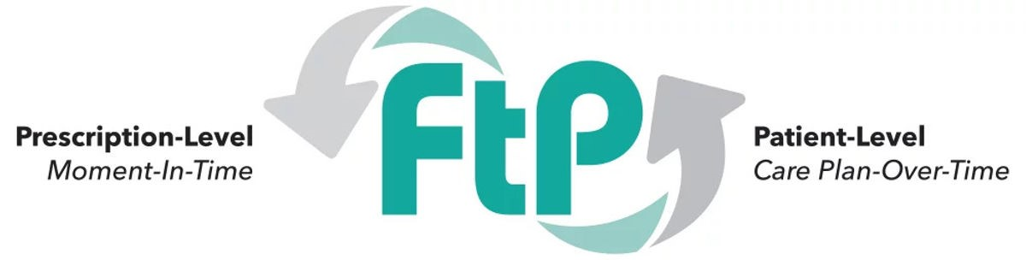
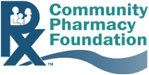
Submit completed application to grants@communitypharmacyfoundation.org by August 6, 2025.

Applicant Name:
Applicant Email:
Applicant Phone Number:

Project Overview
- Background: Provide a description of the project/program that will be implemented with support from this grant funding. (5-7 sentences)

- Project Objective(s): List the project objective(s).

- Needs Assessment/Rationale for the Project/Program: Describe the need this project/program fulfills. (3-5 sentences)

- Opportunity Assessment: Describe the scope of this opportunity. Please include details on factors such as market size, patient interest/demand, payer interest/commitment to the opportunity.

- Describe the revenue model that will support sustainability of this project/program beyond the grant funding. Please do not disclose any specific contract terms in the application.
- Describe the revenue model for this project/program. (e.g., Fee for Service, Value Based Contract, Enhanced Dispensing Fee, etc.)

- Describe the documentation requirements and billing mechanism [e.g., Pharmacy POS claim, eCare plan submission, CPT code (aka, "Medical Claim"), other platform adjudication (e.g., Part D MTM platform)] required for pharmacists/pharmacies to get paid for this service.

- Explain how you will leverage the Flip the Pharmacy practice transformation program (i.e., FtP Domains, FtP Coaches) to support implementation of this project/program.

- Describe how this project/program will be replicated/scaled beyond the grant funding.

Project Team/Collaborative Partners
- FtP Project Team. Complete the table to identify the FtP project team members. Examples of team members to include: Project Manager/Team Lead, FtP Coaches, Data Analyst, etc.
Team Member | Name | Please describe each team member’s experience in community pharmacy practice | Please describe each team member’s experience with FtP

- Community Pharmacies: How many pharmacies will be invited to participate in this project/program? Describe how you will identify/invite community pharmacies to participate in this project/program.

If the information is available at the time of submission, the applicant can complete the table below that includes the name, address, and NPI of pharmacies that have committed to participating in the project/program. If this information is not available at the time the application is submitted, the applicant can include a list of pharmacies that have been invited or will be invited to participate.

Name of Pharmacy | Address of Pharmacy | NPI
- Collaborative Relationships/Partnerships
Please list any collaborative relationships/partnerships (e.g., State Pharmacy Association, College/School of Pharmacy, Department of Health, CDC, Health Plan, Technology Vendor, CPESN Network, Sponsors) that have committed to support the success of this project/program and describe the support they will provide. Letters of support from collaborative partners may be submitted to support the application.
Name of Team Partner | Describe support the partner will provide

- Please describe the capacity and readiness of your project team/community pharmacies/partners to implement the proposed project. If possible, share past successes with similar projects that would demonstrate your ability to implement the proposed project.

Data/Evaluation
- How will you measure the success of this project/program? What data/outcomes will you collect/monitor to evaluate the success of this project/program? Please provide a detailed explanation of how this data will be collected and evaluated.

Question | Response from Applicant
What data will be collected?
What is the source of the data? Who will provide the data (e.g., pharmacist provider, payer, etc.)?
How will the data be analyzed?
How will this data be shared to drive growth and improvement in community pharmacy practice?

Budget/Funding
- Please provide a breakdown of how the funding will be used and a detailed description to justify the resources requested in each budget category in the table below. The categories listed in the table are suggestions and can be revised as necessary.
Category | Amount requested | Please provide a detailed description to justify the resources you are requesting in each category
Team Lead/Project Management
FtP Coaches
Project Administration Costs
Travel
Data Collection
Data Analysis
Other
Total Budget Requested

Please note: CPF does not fund the following: 1. Fringe benefits or indirect costs of any kind (including facilities and/or administrative support); 2. Equipment, software or any expense related to startup systems; 3. Capital expenditures of any kind (building or opening a business, including a community pharmacy).

- Are there other funding sources available to support this project/program? If so, what is the source and amount of the other funding source?
Funding Source | Amount | Describe how the funding will be used to support this project/program

Timeline
- Please include a detailed timeline for implementation of this project/program.

Deliverables/Future Implications
- What deliverables will be produced by this project/program that can be shared with others with the goal of advancing community pharmacy practice? The project must have at least one deliverable that can be posted publicly on the CPF Website and shared widely for the benefit of all of community pharmacies.

- How will the deliverables be shared/disseminated to key stakeholders?

- Describe how this project/program will drive growth and contribute to widespread change in community pharmacy practice.

