


Title
Authors
Organization | City, State

Objectives
- Ensure access to essential prenatal supplements such as iron, prenatal vitamins, and aspirin (if indicated).
- Provide monthly pharmacist check-ins to assess and address maternal health needs.
- Deliver trimester-based screenings and education to promote maternal and infant health.
- Coordinate compassionate, community-based care for pregnant patients.

Methods
Design | The program provides monthly MOMS™ Medications, which include over-the-counter (OTC) prenatal vitamins, iron supplements, and low-dose aspirin when clinically appropriate. Participants can also choose adherence packaging and home delivery to make access easier and more consistent. Each month, participants have check-ins with the pharmacy team, which include screenings for non-medical drivers of health (NMDH) and trimester-specific assessments covering vaccines, mental health, and blood pressure. When vaccine gaps are identified, the team can help schedule and administer vaccines for both the mother and household members. Mental health is supported through depression screening using the PHQ-9 tool, and blood pressure is monitored regularly to ensure safety. All encounters and interventions are documented by the pharmacist.
Study endpoints | Qualitatively define the mothers in the program and quantify interventions
Results
MOMS™ started in August 2025. The pilot included three pharmacies in the Mississippi Delta region. All pharmacies were required to be active members of CPESN MS, CPESN CH, and have a community health worker on staff. By the end of 2025, 43 unique patients received over 99 encounters with pharmacy staff. The average patient age was 26 years, ranging from 18 to 40 years.

The majority of the care was provided by pharmacists (65%). Table 1 is a column chart with the frequency of visits based on pregnancy week for each pharmacy-patient encounter. The majority (84%) of encounters occurred within the first 16 weeks of pregnancy, indicating the availability of pharmacy providers to help patients early in the pregnancy journey. MOMS™ was provided as an in-person service within the pharmacy (41%), in-person at the patient’s home (24%), or via telehealth (35%). Only twenty-three percent of patients had commercial insurance. Forty-three percent had Medicaid, and twenty-three percent were uninsured.

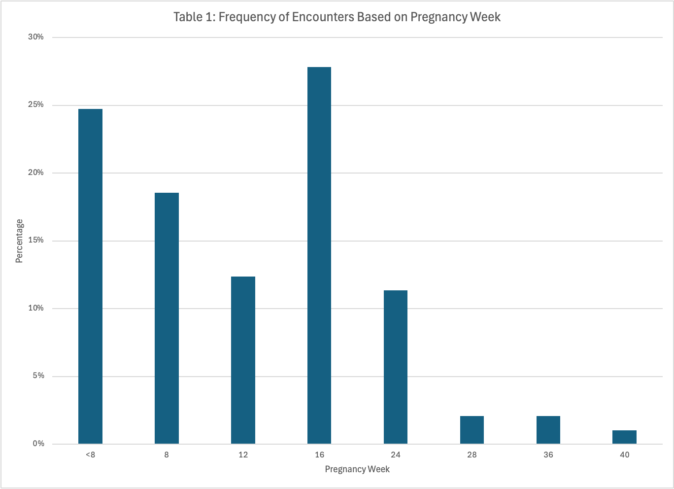

The clinical impacts are also significant. Seventeen percent of patients were started on aspirin by the pharmacy team. Patients were screened and referred for depression (7%) and hypertension (20%). However, the most impact was from the health-related social need (HRSN) screening and referral. Over sixty-five percent of patients had some type of HRSN identified. Often, this was transportation challenges, access to care, or inadequate housing. Take Ashley, for example; She had no transportation, a distrust of vaccines, and was awaiting eviction. The pharmacy was able to establish delivery services for MOMS™ vitamins and iron, coordinate food and housing with a local county resource center, help obtain a breast pump, car seat, and a pack and play from a local hospital, and schedule vaccines with a new OBGYN. All in one encounter.

Conclusion
Community pharmacies are capable of delivering high-quality care to expecting mothers, including adherence support, screenings and referrals for NMDH, vaccines, mental health, and blood pressure.

